THE UNIVERSITY OF AZAD JAMMU & KASHMIR, MUZAFFARABAD


COURSE TITLE | DSA
COURSE CODE | CS-2101
LAB TITLE | POINTERS
STUDENT NAME | HASEEB SHEIKH
STUDENT ROLL NUMBER | 2024-SE-31
INSTRUCTOR NAME | ENGR. SIDRA RAFIQUE
SUBMISSION DATE | OCT 22, 2025

DEPARTMENT OF SOFTWARE ENGINEERING
DSA
Lab 1

Objective:
The primary objective of this lab is to familiarize you with the fundamental concepts and practical usage of arrays in C++.

Problem Statement:
Develop a C++ program that prompts a user to input five integer numbers. The program must then store these numbers sequentially in an array, calculate the total sum of the elements, and determine the largest (maximum) value present in the array. Finally, the program must display all the input numbers, the calculated sum, and the maximum value to the user.

Solution Approach:
The solution uses a sequential processing approach built around a fixed-size array and for loops.
- Declaration: Declare an integer array of size 5 (number[5]) to hold the input values, an integer variable (sum) initialized to 0, and an integer variable (max) to track the largest element.
- Input: Use a for loop that iterates 5 times (from i=0 to i=4). Inside the loop, prompt the user for input and use cin to store the value directly into the corresponding array index (numbers[i]).
- Initialization of Maximum: Crucially, initialize the max variable with the first element of the array (max = numbers[0]). This sets a baseline for comparison.
- Processing (Sum and Max): Use a second for loop to iterate through the array elements again.
- Summation: In each iteration, add the current array element to the sum variable (sum += numbers[i]).
- Maximum Check: Compare the current array element (numbers[i]) with the current value of max. If the array element is greater, update max to the value of that element.
- Output: Use cout to clearly display the original list of numbers, the final calculated sum, and the final maximum value found.

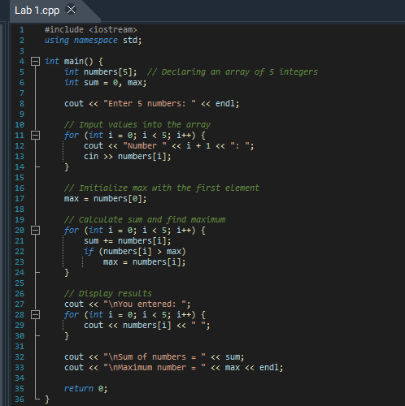
Program:

Explanation:
Code / Section | Explanation
#include <iostream> and using namespace std; | Enables use of standard input/output functions like cin and cout.
int numbers[5]; int sum = 0, max; | Declares an integer array for 5 numbers, initializes sum, and declares max.
Input Loop (for i = 0 to 4 → cin >> numbers[i]) | Takes 5 integers from the user and stores them in the array.
max = numbers[0]; | Sets the first array element as the initial maximum.
Processing Loop (for i = 0 to 4) | Adds all numbers to sum and updates max if a larger value is found.
Display Loop (cout << numbers[i]) | Prints all entered numbers in a single line.
Final Output | Displays the total sum and the maximum number.
return 0; | Terminates the program successfully.

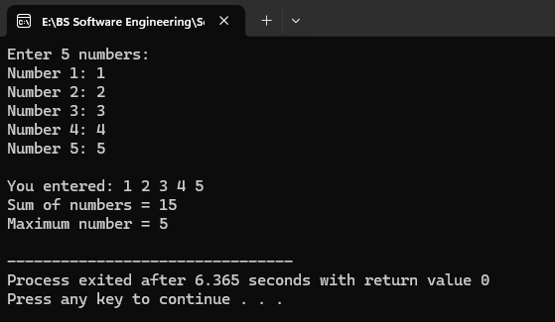
Output:

